

The Significance of 243,349

[**Support AB**](https://artsbus.fcsuite.com/erp/donate/create/fund?funit_id=1003)

[**X**](https://artsbus.fcsuite.com/erp/donate/create/fund?funit_id=1003)

Did you know that a Title I school is a school where 40% or more of the student body

receives a free or reduced fee lunch? What that really means is that these students live

sightly above, at, or below the line of poverty set by the federal government.

San Diego is an area of such abundance, that sometimes it's easy to forget that there

are those among us who simply cannot afford many of the things we take for granted -

like the $15.00 to $25.00 dollars needed to send your child on a school field trip.

As a former teacher, I can share that all students basically require the same things: a

safe school, caring and competent teachers, and access to a range of sound and

enriching educational resources; whether that is a well-supplied classroom, or access to

the enriching informal learning opportunities that occur on field trips to the San Diego Air

& Space Museum, Living Coast Discovery Center or Cygnet Theater.

**Now, about that 243,349.**

According

to

[EdData](https://www.ed-data.org/county/San-Diego)

[,](https://www.ed-data.org/county/San-Diego)

there are 476,760 K-12 students enrolled in public and charter

schools in San Diego County. Out of these, 243,349 qualify for a free or reduced fee

lunch.

**More than half.**

ArtsBusXpress is the

**only organization**

in San Diego County that provides funding

directly to teachers to cover or reduce the cost of field trip bus transportation.

By supporting us, you are removing financial barriers and helping to create equal access

for those 243,349 K-12 students so that they may participate in the incredible learning

opportunities on offer at museums, theaters, zoos, aquariums and science centers

throughout San Diego County.

[**Support AB**](https://artsbus.fcsuite.com/erp/donate/create/fund?funit_id=1003)

[**X**](https://artsbus.fcsuite.com/erp/donate/create/fund?funit_id=1003)

**Teacher's Desk**

“On behalf of Wegeforth Elementary, we

would like to thank you from the bottom of

our hearts for providing buses. It is only

because of this program we were able to

take 3 buses of kids and chaperones to the

San Diego Zoo. Thank you for making this

possible.”

Ms. Alquero

​

Wegeforth Elementary

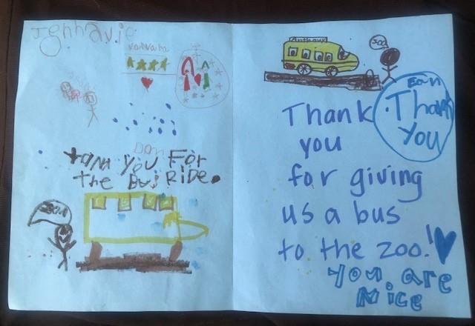

**Tax ID: 20-2793281**

**ArtsBusXpress**

**1804**

**Garnet Avenue, #**

**487**

**San Diego, CA 92109**

**info@artsbusxpress.org**



ArtsBusXpress

|

1804

Garnet Avenue

,

Ste 487

,

San Diego, CA 92109

Unsubscribe artsbusxpressorg@gmail.com

Update Profile

|

[Constant Contact Data Notic](http://www.constantcontact.com/legal/about-constant-contact)

[e](http://www.constantcontact.com/legal/about-constant-contact)

Sent by

artsbusxpressorg@gmail.com

powered by



[Try email marketing for free today](http://www.constantcontact.com/index.jsp?cc=nge&rmc=VF21_CPE&pn=dennergroup&nav=9f7192c9-db2d-4e52-97a7-92d5dda6fe04)

[!](http://www.constantcontact.com/index.jsp?cc=nge&rmc=VF21_CPE&pn=dennergroup&nav=9f7192c9-db2d-4e52-97a7-92d5dda6fe04)